
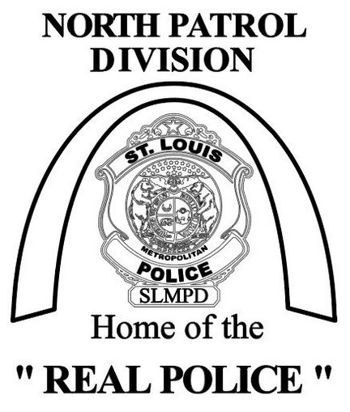

North Patrol Police & Business Partnership
4014 Union Boulevard
Saint Louis, Missouri 63115
Captain William Brown
5th District Commander
Captain Matthew Karnowski
6th District Commander
Major Donnell Moore
North Patrol Commander

Mr. Jim Pennington
North Patrol Police & Business Partnership President

2025 Membership Application and Renewal Form

We appreciate your membership and would ask you to encourage other businesses within the Fifth District and Sixth District to join us in support of the Police Officer at the North Patrol Division.

Please make your check payable to the North Patrol Police & Business Partnership. You can mail to the below address or arrange a time for pick up by a North Patrol Division Police Officer.

North Patrol Police & Business Partnership
4014 Union Boulevard
St. Louis, MO. 63115
Attention: Sergeant Erin Becherer – Sergeant, North Patrol Division

If you have any questions or want to arrange for the check to be picked up, please contact Sergeant Erin Becherer, North Patrol Station Executive Officer @ 314-444-0050 or eebecherer@slmpd.org.

*********************************************************************************************************************************

_______________________________________ Select your annual contribution level & type:
Business Name/Current Resident
[ ] Resident Sponsorship $25
_______________________________________
Business/Resident Address & Zip Code [ ] Bronze $100
_______________________________________
Contact Person [ ] Silver Member $250

__________________ __________________ [ ] Gold Member $500
Phone E-mail address
[ ] Platinum Membership $1,000+
*Gold and Platinum Members will be invited to a BBQ with the [ ] Other amount _____________
North Patrol Division Officers at 4014 Union.

